**Lab – 47: How to configure Wi-Fi settings in Microsoft Intune?**

**Objective:** The objective of this lab is –

* To configure Wi-Fi settings in Microsoft Intune.

Use Microsoft Intune Wi-Fi profiles to assign wireless network settings to users and devices in your organization. When you assign a Wi-Fi profile, your users will have access to your corporate Wi-Fi network without having to configure it themselves. In this lab, we are going to configure Wi-Fi settings for a particular group of employees in an organization.

**Prerequisite:** EMS Enterprise Mobility + Security E5.

**Steps:**

1. Sign in to your Azure Portal, by using the link - **https://portal.azure.com/**. Enter your credentials and click Sign In.

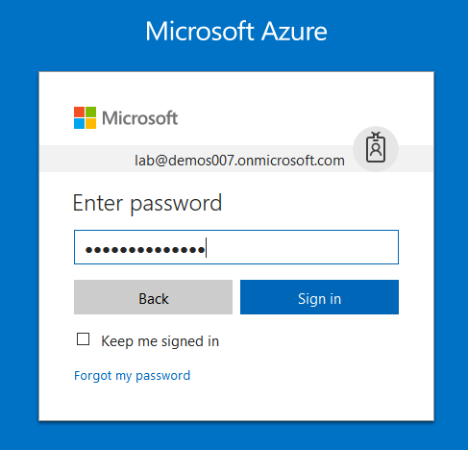

1. Microsoft Azure AD Dashboard will open.

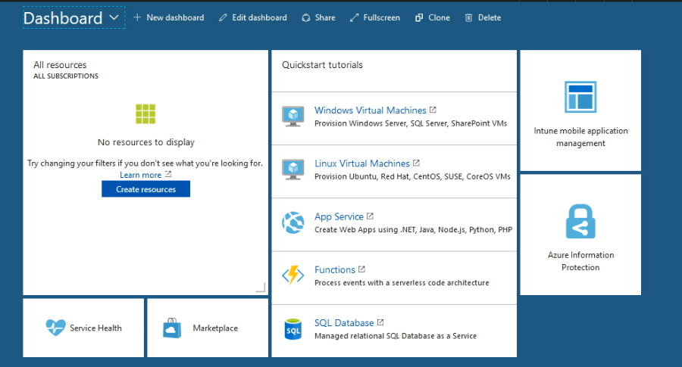

1. Open **Microsoft Intune** service from the left-hand side of the Azure portal.
2. Once you've opened the **Microsoft Intune** blade, select **Device Configuration**.

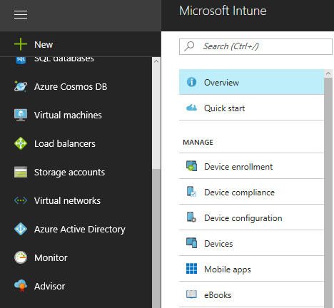

1. On the **Device Configuration** blade, choose **Manage** > **Profiles**.

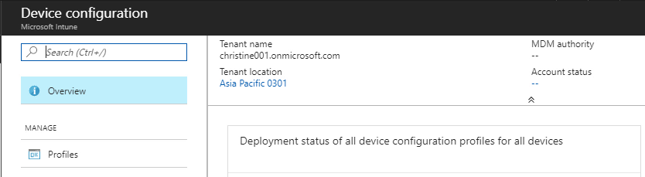

1. On the blade showing the list of profiles, choose **Create Profile**.

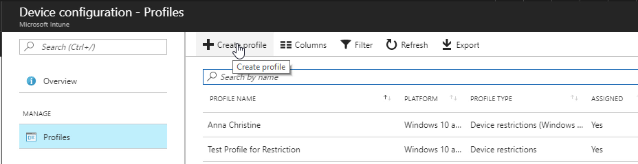

1. On the **Create Profile** blade, specify the items:

Name - Enter a descriptive name for the new profile.

Description - Enter an optional description for the profile.

Platform - Select the platform type for the profile you want to create. Here, select **Android**.

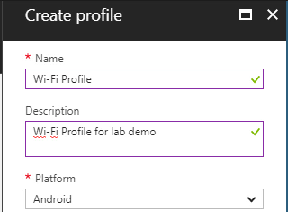

Profile type – select W-Fi from the drop-down menu.

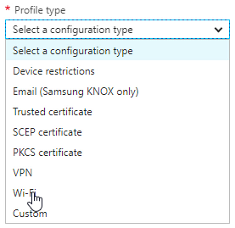

1. Then configure the settings, from the **Wi-Fi type** drop-down list, choose **Wi-Fi basic** or **Wi-Fi enterprise**. Here, choose Wi-Fi Basic.

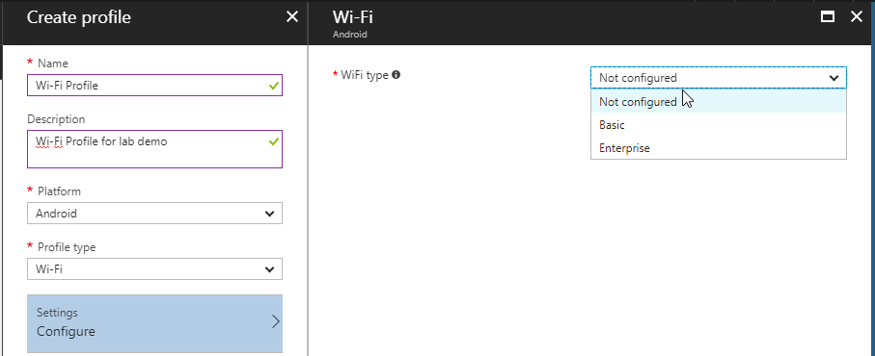

1. Supply basic features like the SSID. Enable or Disable - Connect Automatically and Hidden Network as per your requirement.

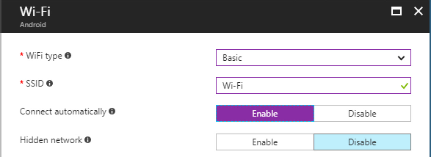

1. Then select **OK**.
2. When you're done, go back to the **Create Profile** blade, and hit **Create**.
3. Now you can see Wi-Fi profile is created successfully and appears on the profiles list blade.

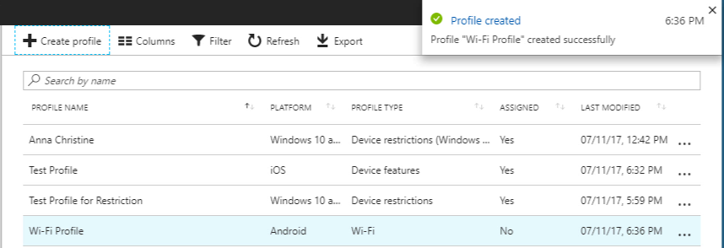

1. Then assign this profile to groups. By clicking on **Manage** > **Assignment**s in the created profile blade.

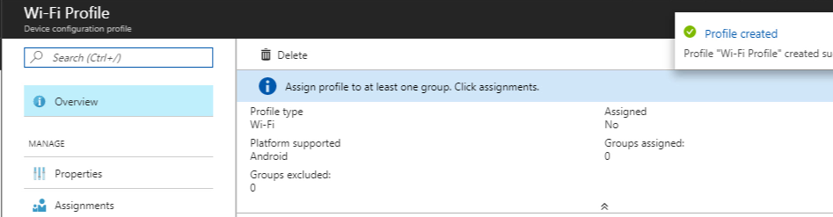

1. On the next blade, choose either **Include** (to include groups) or **Exclude** (to exclude) or both one by one to include and exclude the groups.

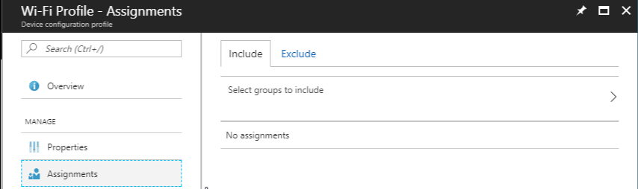

1. And, select a group to include and exclude as per your selection. You can hold down the CTRL key to select multiple groups. Then click Select.
2. After including and excluding the groups click **Save**, in the assignments blade. Also you will get assignments saved successfully notification at the top right corner.

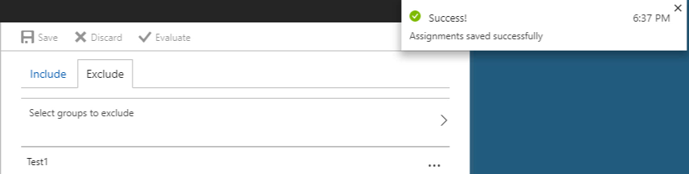

1. Also you can go to properties and check the configurations you made.

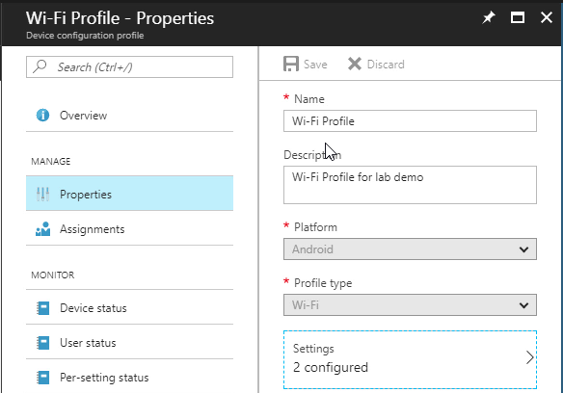

1. So, in this way you can configure Wi-Fi settings in Microsoft Intune.